Photographs related to the proposed multi-grain flour innovation are attached below.

These images represent the raw materials (Ragi, Bajra, and Maize), the preparation process including cleaning, mixing, and grinding, and the final product concept.

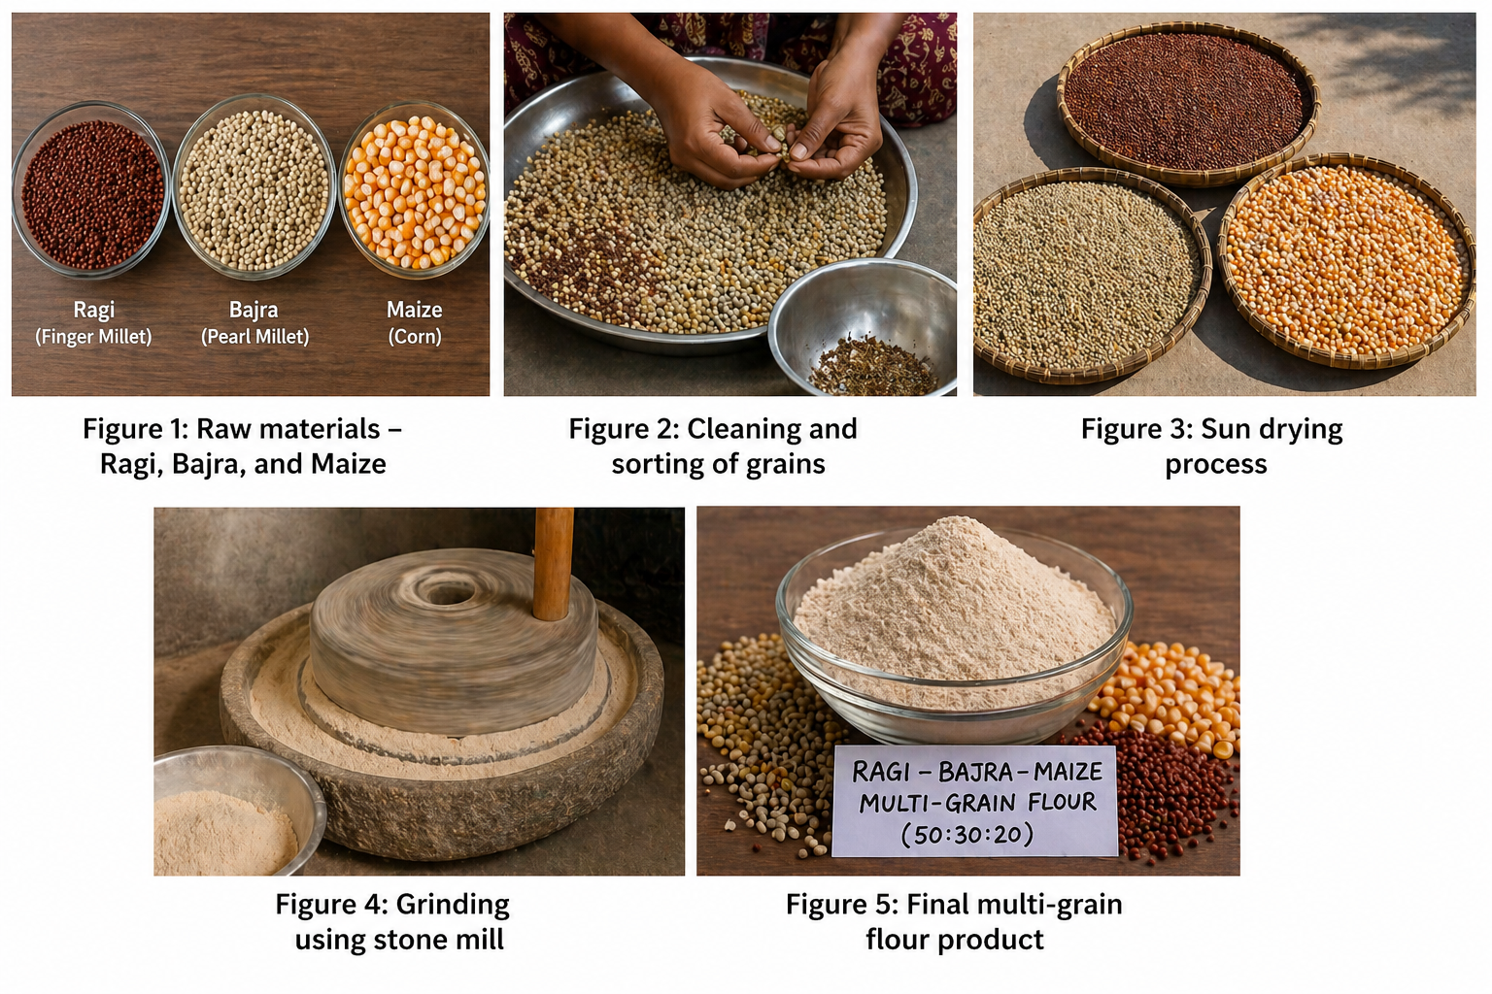

The photos demonstrate the practical feasibility of the idea and the step-by-step process involved in developing the nutrient-dense multi-grain flour.

This documentation supports the proposed innovation under the Nutrihub NSTEP program.

